Phase 1
Vulnerability Scanning Report

Objective
The Objective of this phase was to perform Vulnerability Scanning using multiple tools like Nmap, Nikto, OpenVAS(Greenbone) which are commonly available in Kali Linux Environment. The Goal is to identify outdated services and identify unwanted/misconfigured ports.

Tools used
- Nmap
- OpenVAS
- Nikto
- Kali Linux

Methodology
- Network scanning using Nmap.
A port scan was launched using the command given below:
Command: nmap -sC -sV <target-ip> -oN nmap_scan.txt
The scan Results are attached to this document and further ahead a sample extract is provided.
- Web Vulnerability Scanning using Nikto
Nikto was used to perform the scan on the target.
Command: nikto -h http://<target-ip>
The above scan was saved in several formats for demonstration purposes which are attached to this document phase folder.

- OpenVAS Vulnerability Scanner.
OpenVAS was used to perform Full Vulnerability scan on this Target IP Address. The scan was configured Full and fast. It also resulted in pdf containing full of information about vulnerabilities. This document is also attached.

Findings table
The Below table represents the vulnerabilities present with the appropriate CVSS score and priority.

Vulnerability Assessment Table
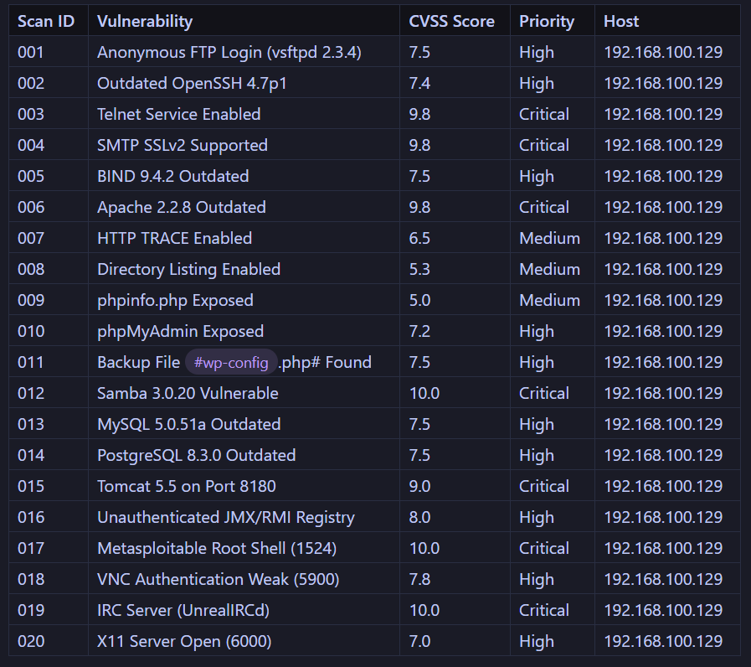

Critical Vulnerabilities
CVE-2010-2861 – Apache 2.2.8 Directory Traversal
- Description: The Apache running in the target machine contains Directory traversal vulnerability which allows unrestricted access of server files.
- Impact: Exposure of config-files, credentials, or unauthorized web content.
- Remediation: Update Apache to the Latest Version Available to Resolve the issue.

Escalation:
Subject: Apache Vulnerability found (Critical).
Hi Team,
During the vulnerability scanning performed on the Target VM, we found a Critical Vulnerability related to the Apache web server running in the target. It allows unrestricted Directory Traversal, exposing server files, Configuration files, Other sensitive Information. I recommend to update the Apache to the latest version available to resolve this issue as soon as possible.

Thanks,
Supreet

